Double Your Media Effectiveness +
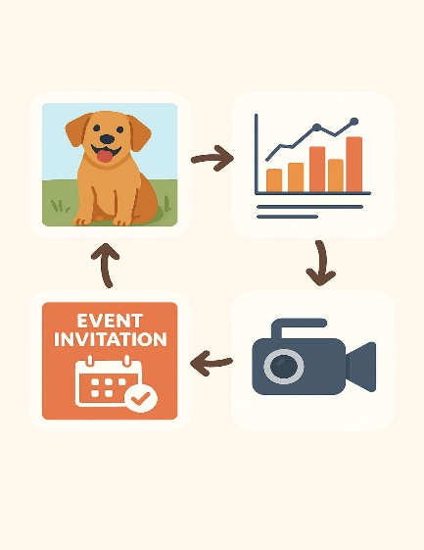
It goes without saying, but I’ll mention it here this once, that you are keeping your donors informed with milestones, achievements and everyday happenings at your organization. They feel invested in your success and involved as an “insider” in the organization thanks to your communications initiatives. Let’s talk about your pipeline of communications – the daily stories you seek out that speak to the services your organization provides, leverages happenings that are trending in the news and otherwise relates to the interests of your stakeholders.

An easy way to amplify your successes, ongoing challenges and activities is to adapt and repeat your stories and posts across diverse media platforms. One picture may be worth a lot more than a thousand words when it comes to clicks magnified by a website blog, Instagram, Facebook and TikTok post, with a link to a YouTube video. A LinkedIn post about a conference at which one of your executives presented can be edited to a digestible visual and link for multiple social media platforms. A longer version can be posted on your website or in a format for industry professionals.
You don’t want all your media to be the same, but adding features that are built-in for each platform, such as video or graphics, can make the same content appear fresh and suited for the particular platform. Leave room in your content schedule for the unexpected element that will reinforce messaging across the board.

